India is the second largest clay brick manufacturer in the world after China. It is also one of the major coal consuming sectors of India. The most prevalent Fixed Chimney Bull’s Trench (FCBT) type brick kiln produces around 80% of the first grade quality brick. This can be improved using heat efficient methods. With reference to this, an air circulation system has been developed to improve the thermal efficiency of the brick kilns. The brick kiln has mainly four zones: the drying zone, the preheating zone, the firing/combustion zone, and the cooling zone. The invented system increase the heat transfer rate from the surface of the fired bricks in the cooling section and supplying pre-heated air to the firing zone of the brick kiln. This provides a uniform heating in the firing zone of the brick kiln and thus increased the percentage of top quality bricks to 90%, an increment of ~10% from the conventional. Fig.1 shows the initiatives taken by CSIR-IIP to improve the thermal performance of the brick kilns.
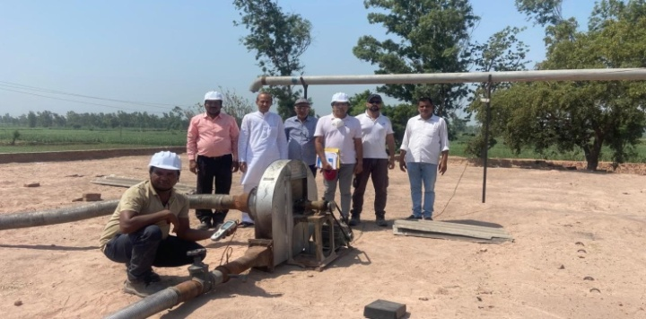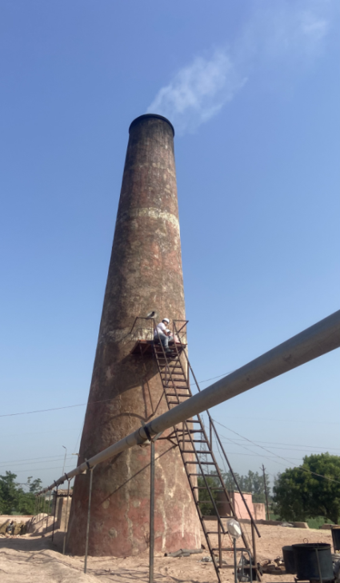
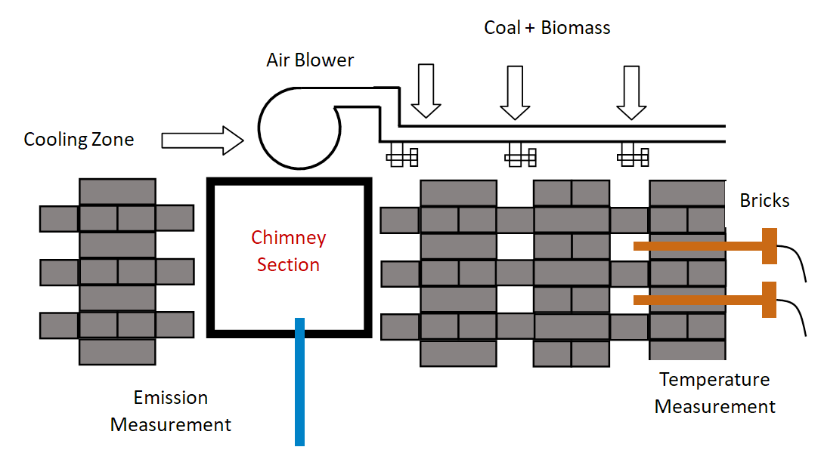

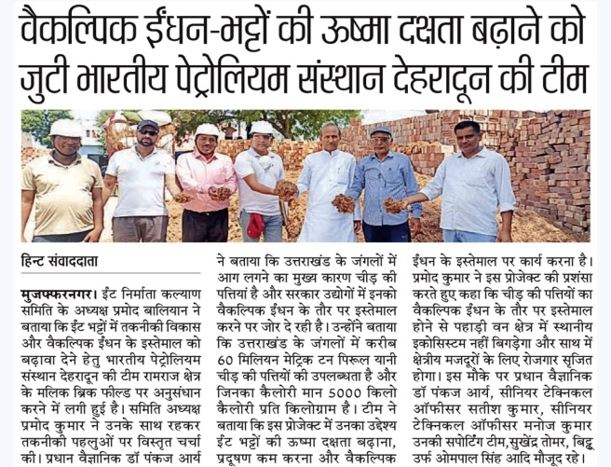

Fig.1: CSIR-IIP Initiative to improve the brick kiln efficiency

